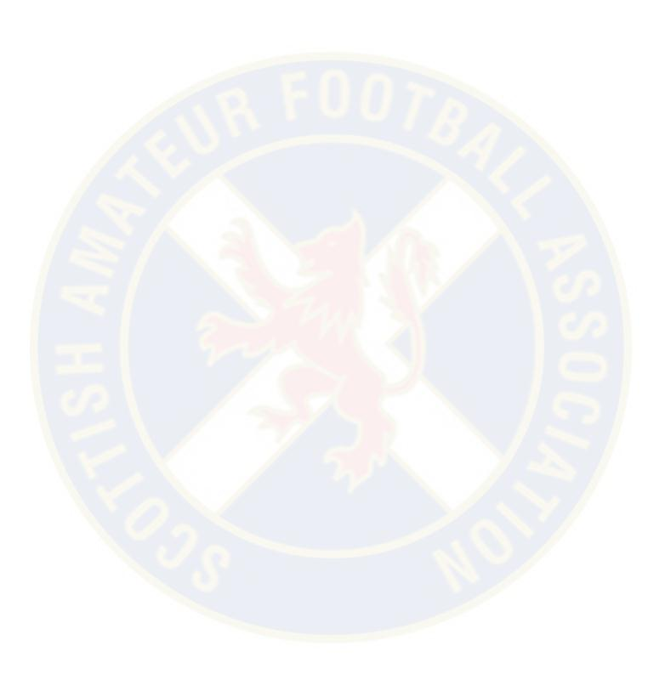
The Scottish Amateur Football Association
Affiliated to the Scottish Football Association
Friendly Matches
Application Form & Guidelines

Club:
League / Association:
Name of Applicant:
Address:
Post Code:
Telephone Number:
Mobile Number:
E-Mail Address:

Rule 5:
Tournament and Friendly Matches
Clubs wishing to participate in a tournament or friendly match must apply for the appropriate permission as follows: -
Friendly fixture against a club in membership of own Association/League permission of own Association/League
Friendly Match against Club in membership of the Scottish Amateur Football Association. Permission of own League / Association and Scottish Amateur Football Association.
Friendly Match against Club not in membership of the Scottish Amateur Football Association permission of own League / Association, the Scottish Amateur Football Association and where appropriate the S.F.A. Ltd. which will be obtained by the Scottish Amateur Football Association.
Tournaments within and outwith Scotland
Permission of own League/Association, the Scottish Amateur Football Association and where appropriate the S.F.A. Ltd. which will be obtained by the Scottish Amateur Football Association.
Any match which takes place without the necessary permission will be deemed to be unauthorised football and will be referred to the relevant committee which may result in disciplinary action being taken against the Club involved.
The reasons for any member club failing to adhere to the requirements of this rule will be investigated by the Executive Committee and if deemed unsatisfactory the defaulting club will be fined a sum not greater than £50.00.

Opponents & their League / Association | Date of Match  DD/MM/YY | Opponents Town or City | Town or City & County of Venue

